**Name:** Kenni Leslie

**Assignment #6**

**Description:**

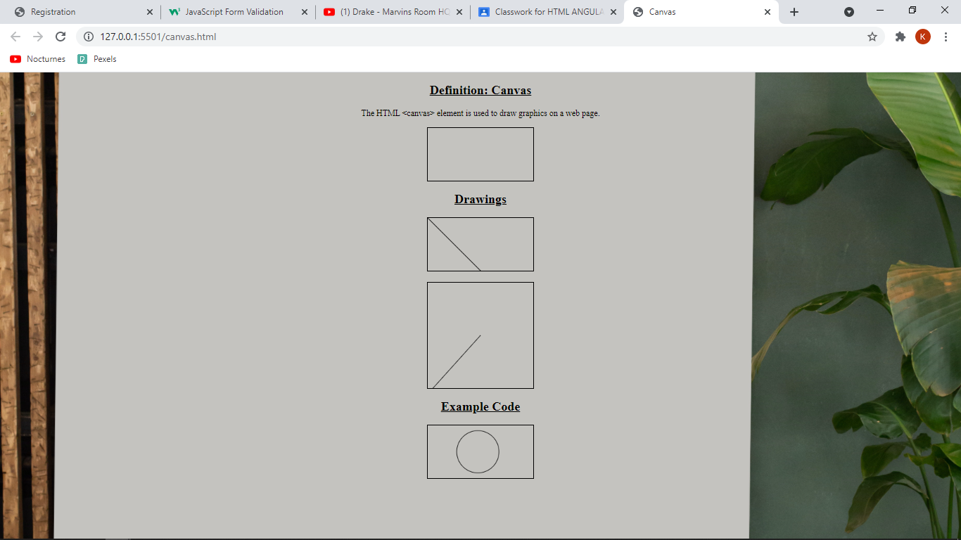

canvas.html

<!DOCTYPE html>

<html lang="en">

  <head>

    <meta charset="UTF-8" />

    <meta http-equiv="X-UA-Compatible" content="IE=edge" />

    <meta name="viewport" content="width=device-width, initial-scale=1.0" />

    <title>Canvas</title>

    <style>

      h2 {

        text-decoration: underline;

        text-align: center;

      }

      body{

        background:url(./img/pexels-monstera-6373658.jpg)center/cover no-repeat;

      }

      canvas{

        margin-left: auto;

        margin-right: auto;

        display: block;

      }

    </style>

  </head>

  <body><main><div>

      <h2>Definition: Canvas</h2>

      <p style="text-align: center;">

        The HTML &lt;canvas&gt; element is used to draw graphics on a web page.

      </p>

      <canvas

        id="emptyCanvas"

        width="200"

        height="100"

        style="border: 1px solid #000000"

      >

        Your browser does not support the HTML canvas tag.

      </canvas>

    </div>

    <div>

      <h2>Drawings</h2>

      <canvas

        id="myCanvas"

        width="200"

        height="100"

        style="border: 1px solid #000000"

      >

        Your browser does not support the HTML canvas tag.</canvas

      >

      <script>

        var c = document.getElementById("myCanvas");

        var ctx = c.getContext("2d");

        ctx.moveTo(0, 0);

        ctx.lineTo(200, 200);

        ctx.stroke();

      </script>

<br>

      <canvas

        id="myCanvas0"

        width="200"

        height="200"

        style="border: 1px solid #000000"

      >

        Your browser does not support the HTML canvas tag.</canvas

      >

      <script>

        var a = document.getElementById("myCanvas0");

        var ctx1 = a.getContext("2d");

        ctx1.moveTo(10, 200);

        ctx1.lineTo(100, 100);

        ctx1.stroke();

      </script>

    </div>

    <h2>Example Code</h2>

    <canvas

      id="myCanvas2"

      width="200"

      height="100"

      style="border: 1px solid #000000"

    >

      Your browser does not support the HTML canvas tag.</canvas

    >

    <script>

      var r = document.getElementById("myCanvas2");

      var ctx2 = r.getContext("2d");

      ctx2.beginPath();

      ctx2.arc(95, 50, 40, 0, 2 * Math.PI);

      ctx2.stroke();

    </script></main>

  </body>

</html>